Shrinkage correlation: NZDUSD and USDCHF
Method 08 / eight-major panel / delta = 0.2 and Ledoit-Wolf / Alpari D1 full available history

Study setup
Logical pair: NZDUSD , USDCHF
Broker symbols: NZDUSD_i , USDCHF_i
Snapshot: 2026-11-03_majors_alpari_D1
Timeframe: D1
Common eight-major panel window: 1999-01-06 to 2026-11-02 (UTC bar dates)
Panel matched return count n: 7127
Dropped unfinished last bar dated 2026-11-03 UTC after a tick-volume check against the prior complete day.
Fixed shrinkage: delta=0.2, mu=3.9170889e-05 (mean of diag(S))
Ledoit-Wolf estimated delta: 0.0042157642
Panel symbols: EURUSD, GBPUSD, AUDUSD, NZDUSD, USDJPY, USDCHF, USDCAD, EURGBP
Complete matched rows (Excel): NZDUSD-USDCHF_Shrinkage_D1.xlsx
Complete matched rows (HTML table): NZDUSD-USDCHF_Shrinkage_D1_data.html

Method carried forward
Shrinkage blends the sample covariance matrix S of matched daily log returns of close, ln(close_t / close_t-1), toward a simple target, then converts the shrunk covariance into correlations. Quotes are not inverted. This experiment builds one common calendar across all eight majors, forms S with the unbiased n-1 divisor, then reports two shrinkage specs: fixed delta = 0.2 with mu equal to the average sample variance (mu * I target), and sklearn Ledoit-Wolf with its estimated delta. Pair reports pull rho_ij from those panel matrices. Same-panel Pearson r is a side check only. Shrinkage improves conditioning; it is not a cause, not a lead, and not a trading signal.

Results
pearson_r | rho_02 | rho_LW | rho_02_minus_r | rho_LW_minus_r | delta_LW
-0.394447 | -0.329777 | -0.393139 | 0.06467 | 0.001308 | 0.00421576

Conclusion
Over the common 7127-day eight-major panel for NZDUSD and USDCHF (broker quote directions unchanged), fixed-delta shrinkage correlation at delta=0.2 is -0.3298 (negative, weak linear link in this sample). Ledoit-Wolf rho is -0.3931 with estimated delta=0.004216. Same-panel Pearson r is -0.3944 (rho_02 minus r = 0.0647; rho_LW minus r = 0.0013). This does not establish cause, lead-lag, or a lasting trading rule.

Charts
Daily closes
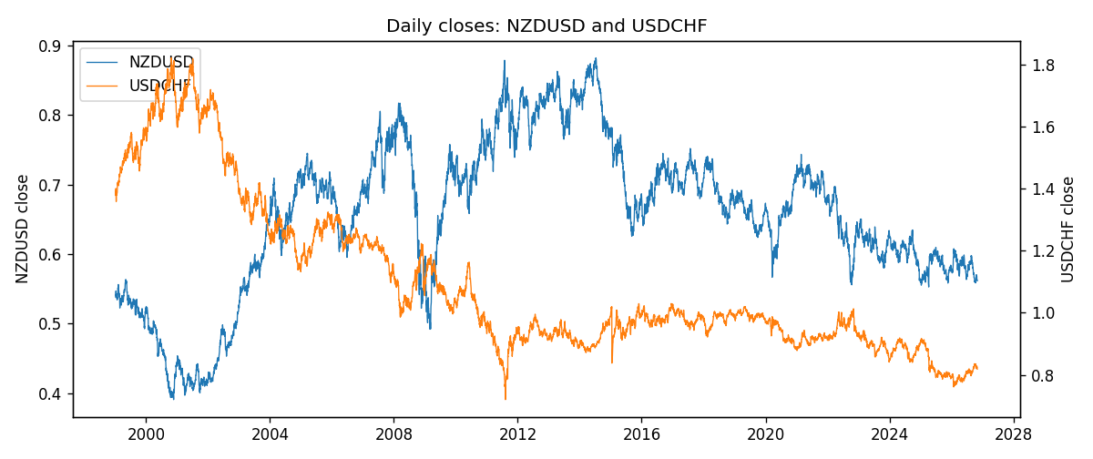
Daily log returns
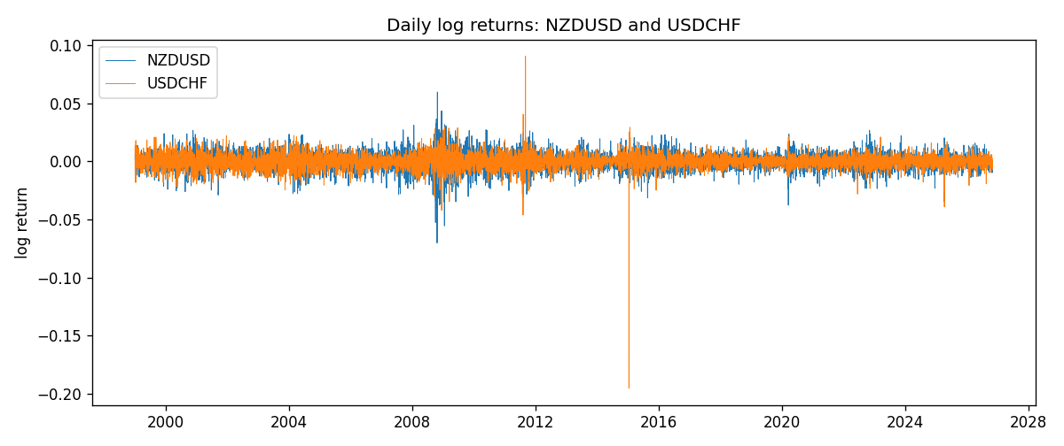
Log-return scatter
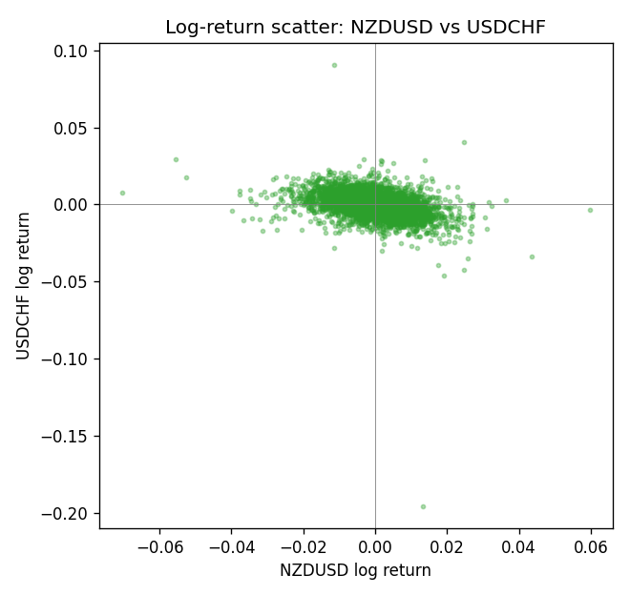

Data report
Every panel row for this pair slice is stored in the sibling Excel workbook named NZDUSD-USDCHF_Shrinkage_D1.xlsx. Full-panel covariance and correlation matrices are saved once under outputs/ as CSV files. Embedding all rows as a Word table is impractical at this length; the Word file holds the column list, column summaries, and the first and last 15 matched rows.
Columns: time, NZDUSD_open, NZDUSD_high, NZDUSD_low, NZDUSD_close, NZDUSD_tick_volume, NZDUSD_spread, NZDUSD_real_volume, NZDUSD_log_return, USDCHF_open, USDCHF_high, USDCHF_low, USDCHF_close, USDCHF_tick_volume, USDCHF_spread, USDCHF_real_volume, USDCHF_log_return
Column summaries (panel rows)
column | count | mean | std | min | 25% | 50% | 75% | max
NZDUSD_open | 7127 | 0.65707489 | 0.10792246 | 0.3913 | 0.59224 | 0.66889 | 0.725215 | 0.88218
NZDUSD_high | 7127 | 0.66100044 | 0.10841069 | 0.3961 | 0.595625 | 0.6726 | 0.72964 | 0.88421
NZDUSD_low | 7127 | 0.65338952 | 0.10751648 | 0.3897 | 0.588615 | 0.6651 | 0.721335 | 0.87988
NZDUSD_close | 7127 | 0.65715675 | 0.10791625 | 0.3907 | 0.5923 | 0.66906 | 0.725335 | 0.8822
NZDUSD_tick_volume | 7127 | 69244.396 | 123501.01 | 17 | 5842 | 34224 | 58735 | 1127682
NZDUSD_spread | 7127 | 30.023572 | 25.540824 | 0 | 9 | 17 | 40 | 80
NZDUSD_real_volume | 7127 | 1.6834718e+10 | 8.5315436e+10 | 0 | 0 | 0 | 0 | 2.705649e+12
NZDUSD_log_return | 7127 | 2.447e-05 | 0.00764665 | -0.07027433 | -0.00423198 | 0.00024001 | 0.00459119 | 0.05966839
USDCHF_open | 7127 | 1.0950724 | 0.25120393 | 0.72022 | 0.92018 | 0.98921 | 1.23375 | 1.8219
USDCHF_high | 7127 | 1.1003422 | 0.25292835 | 0.73305 | 0.924355 | 0.99265 | 1.2388 | 1.8313
USDCHF_low | 7127 | 1.0899719 | 0.24962782 | 0.08565 | 0.91675 | 0.98562 | 1.22815 | 1.8121
USDCHF_close | 7127 | 1.0950652 | 0.25109829 | 0.72025 | 0.92039 | 0.98915 | 1.23375 | 1.8217
USDCHF_tick_volume | 7127 | 74858.54 | 113805.19 | 350 | 12933.5 | 40528 | 70784 | 858589
USDCHF_spread | 7127 | 25.804827 | 24.609722 | 0 | 5 | 16 | 50 | 100
USDCHF_real_volume | 7127 | 2.3477824e+10 | 8.9470976e+10 | 0 | 0 | 0 | 0 | 1.9331921e+12
USDCHF_log_return | 7127 | -7.023e-05 | 0.006591 | -0.19545699 | -0.00334576 | 8.055e-05 | 0.00331687 | 0.09051364
First 15 panel rows (selected columns)
time | NZDUSD_close | USDCHF_close | NZDUSD_log_return | USDCHF_log_return
1999-01-06 | 0.5383 | 1.3912 | 0.0020455609 | 0.013605652
1999-01-07 | 0.5417 | 1.3782 | 0.0062963171 | -0.0093883841
1999-01-08 | 0.5414 | 1.3935 | -0.00055396548 | 0.011040268
1999-01-11 | 0.547 | 1.4009 | 0.010290425 | 0.0052963193
1999-01-12 | 0.5441 | 1.3872 | -0.0053157489 | -0.0098275602
1999-01-13 | 0.5387 | 1.3621 | -0.0099742238 | -0.018259701
1999-01-14 | 0.5386 | 1.3588 | -0.00018564931 | -0.0024256692
1999-01-15 | 0.5382 | 1.3834 | -0.00074294208 | 0.01794228
1999-01-18 | 0.5372 | 1.379 | -0.0018597736 | -0.0031856384
1999-01-19 | 0.5382 | 1.3789 | 0.0018597736 | -7.2518946e-05
1999-01-20 | 0.5404 | 1.3889 | 0.0040793678 | 0.0072259871
1999-01-21 | 0.5426 | 1.3836 | 0.0040627941 | -0.0038232689
1999-01-22 | 0.5361 | 1.3834 | -0.012051689 | -0.0001445609
1999-01-25 | 0.5342 | 1.3868 | -0.0035504102 | 0.0024546976
1999-01-26 | 0.5381 | 1.3897 | 0.0072741158 | 0.0020889617
Last 15 panel rows (selected columns)
time | NZDUSD_close | USDCHF_close | NZDUSD_log_return | USDCHF_log_return
2026-10-13 | 0.56127 | 0.83244 | 0.0047326165 | -0.0024955621
2026-10-14 | 0.55918 | 0.83489 | -0.0037306483 | 0.0029388325
2026-10-15 | 0.56185 | 0.82676 | 0.0047634855 | -0.0097855323
2026-10-16 | 0.56509 | 0.82377 | 0.0057501001 | -0.0036230826
2026-10-19 | 0.56616 | 0.82677 | 0.0018917133 | 0.0036351779
2026-10-20 | 0.56827 | 0.8246 | 0.0037199341 | -0.0026281224
2026-10-21 | 0.57003 | 0.82427 | 0.0030923331 | -0.00040027413
2026-10-22 | 0.56815 | 0.82032 | -0.0033035227 | -0.0048036381
2026-10-23 | 0.56991 | 0.82497 | 0.0030929853 | 0.005652514
2026-10-26 | 0.56826 | 0.82649 | -0.0028993932 | 0.0018407959
2026-10-27 | 0.56811 | 0.82865 | -0.00026399852 | 0.0026100526
2026-10-28 | 0.56261 | 0.82781 | -0.0097283914 | -0.0010142111
2026-10-29 | 0.56296 | 0.82379 | 0.00062190714 | -0.0048680164
2026-10-30 | 0.56307 | 0.82438 | 0.00019537668 | 0.00071594559
2026-11-02 | 0.56161 | 0.81851 | -0.0025962955 | -0.0071459744

